SSH & Backup & Remote Data Transfer

Ssh: secure shell
used for securely login to remote server and execute command.
it can transfer file securely through scp (secure copy) protocol
package or software name : openssh
service = sshd
port/address = 22
configuration path = /etc/ssh/sshd_config
SSH advantage over Telnet/RSH :
- Ssh is more secure
- Ssh encrypt data while telnet send in plain text
- Ssh usage asymmetric encryption
encryption: encryption is the process that encode the message or file that can only read by certain people
encryption usage an algorithm to encrypt the data and then usage the key for the receiving party to decrypt the data
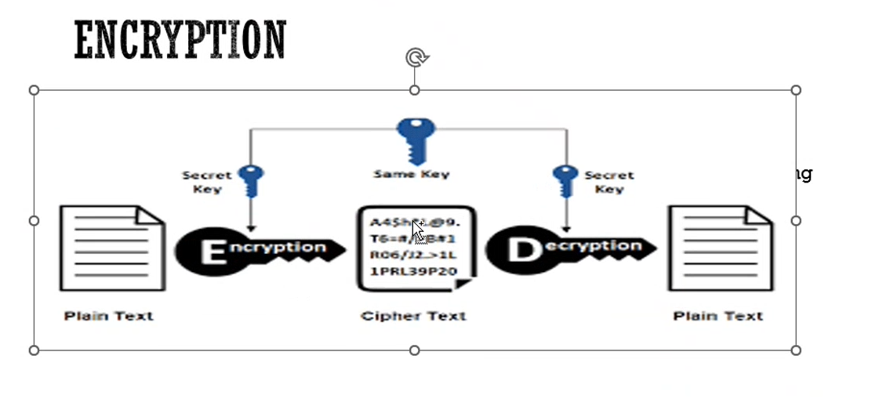
2 types of encryption
- Symmetric encryption
- In this encryption when user a want to transfer data to user b then user a encrypt the data using key and only this key can decrypt this then this user transfer the data with key to user b then user b decrypt the data using the key that he received.
but in this one problem when this key during transferring from user a to user b it stole d or get this key to hacker this may leads to problem.
it is also called as a one layer encryption.
it is fast
- Asymmetric encryption
a. in this encryption usage the 2 key a) public key b) private key
b. in this encryption when data is encrypted by private key then it decrypted only public key and vice a versa.
in this encryption when user a want to transfer data to user b then both have their public and private key. User a request to user b for public key then user a encrypt data with public key of user b and transfer to user b and then user b have their private key to decrypt this.
it is slow as compared to symmetric key
when we firstly login to server through ssh like ssh admin@192.168.1.28 then it first ask yes or not if we enter yes it pulls the public key and stored I /root/.ssh/known_hosts file.
and we make the another times to connect them it doesn’t ask the yes or no cause it is already present.
but in this passwd requires to login/



without passwd login or passwdless login( key based authentication)
when server 1 have public and private key
server 2 have public and private key
when server 2 copy public key to server1 this time server2 ask passwd and same time it pull public key of server2
when 2nd time when server1 make request to server2 then server2 have already have public key then server2 make assure that it coming from server1 or not so make one challenge encrypt with public kay of server1 and send to server1 and it decrypt correctly by server 1 then server 2 make an without passwd authentication.
by default port of ssh is 22 but we can change this to another port and get access by this command for the security purpose.
ssh -p 23 admin@192.168.1.28
also by the security purpose passwd is also disabled we can login server only through keys.

Ssh -i <key-name> admin@192.168.1.28

When we want to disable the root login
change permitlogin NO in the /etc/ssh/sshd_config
when we want to disable the passwd login use this
change the PasswordAuthentication no then we can only access the through private key .
when we want to give ssh access to specific user and other user’s don’t provide the ssh access add this entry in this configuration file
allowusers karan kolhe namita
or we want to give all user ssh access and prevent from some user add this line in confi
denyusers karan
scp(secure copy) vs rsynk(remote synchronize)

🔹 Feature | 🔐 scp (Secure Copy) | ⚡ rsync (Remote Sync)
📦 What it does | Copies files via SSH (one-time) | Syncs files/folders (smartly)
🔄 Sync support | ❌ Copies everything every time | ✅ Only copies changes (faster)
⏸ Resume support | ❌ No resume | ✅ Can resume if interrupted
💨 Speed | Slower for big data | Faster with delta transfer
🎛 Compression | ❌ Not by default | ✅ Use -z for compression
🔒 Security | ✅ SSH | ✅ SSH or native rsync daemon
🎯 Best for | Simple, one-time transfers | Backups, syncing, automation

# scp: Copy file to remote
scp file.txt user@host:/path/

# rsync: Sync folder to remote with compression and progress
rsync -avz --progress folder/ user@host:/path/

tar:
for compress the directory
tar -cvf karan.tar karan

for extract
tar -xvf karan.tar
zip:
for zip the directory
zip Desktop.zip Desktop
for unzip the directory
unzip Desktop.zip
4. Add files to an existing zip:
zip myarchive.zip newfile.txt
If myarchive.zip already exists, newfile.txt will be added to it.

gzip:
gzip compresses only files, not directories.
in this original file is converted into gzip file
gzip [options] filename
gzip text
when we want to unzip them use this
gunzip filename.gz

when we want to compress file maximum use this
gzip -9 filename
bzip2:
it is similar to gzip and it is advanced version of gzip and both gzip and bzip2 are worked on files not an directory.
bzip2 filename
for compress the files. Original files deleted and create another one with extension filename.bz2
when want to uncompressed the file
bunzip2 filename.bz2
when we want to compress file with maximum compression
bzip2 -9 filename
Tool | Type | Handles Directories? | Compression? | Output Extension | Notes
tar | Archiver | ✅ Yes | ❌ No (on its own) | .tar | Combines files into one, no compression by default
zip | Archiver + Compressor | ✅ Yes | ✅ Yes | .zip | All-in-one tool; widely used, especially in Windows
gzip | Compressor | ❌ No (files only) | ✅ Yes | .gz | Needs tar to compress folders
bzip2 | Compressor | ❌ No (files only) | ✅ Better compression than gzip | .bz2 | Slower than gzip, but higher compression

